Name:

MATHS A

Cumulative Frequency Graphs:

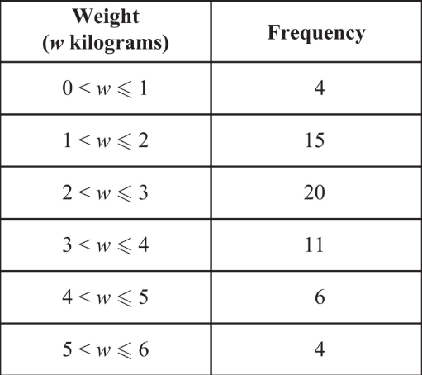Q1. The frequency table gives information about the weights, in kilograms, of 60 parcels in a delivery van.

1. 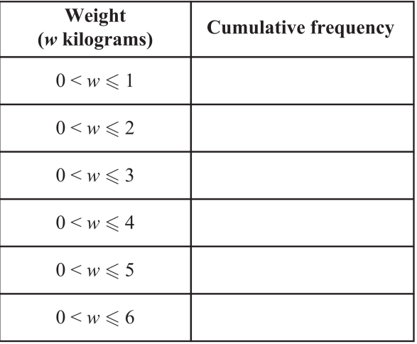Complete the cumulative frequency table. [1]
2. On the grid opposite, draw a cumulative frequency graph for your table. [2]
3. 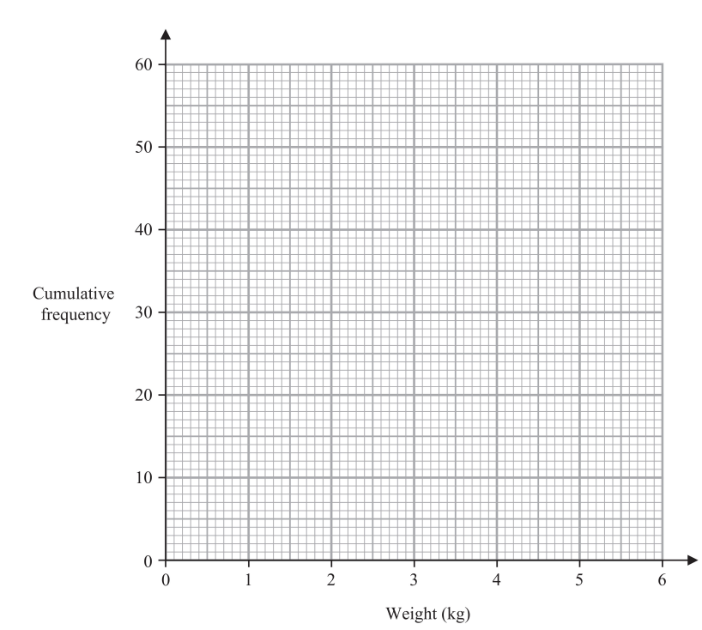Use your graph to find an estimate for the median weight of the 60 parcels. [1]
4. Use your graph to find an estimate for the number of these parcels that weigh more than 3.7 kilograms. [2]

[OCT24 2H Q13]

Q2. The cumulative frequency table gives information about the time, in hours, that each of 60 workers spent working from home in one week.

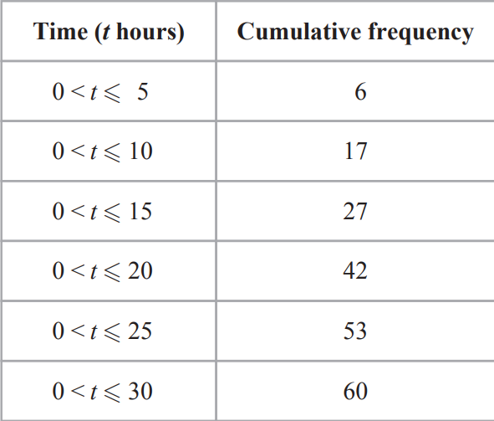

1. 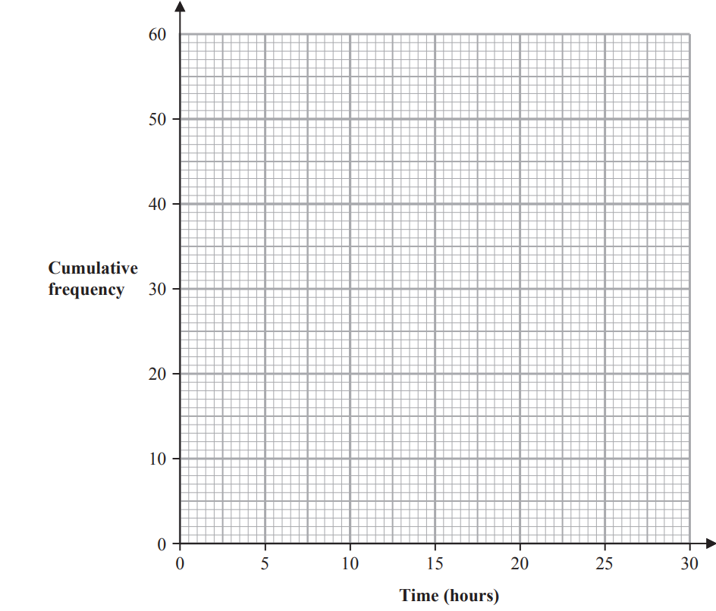On the grid below, draw a cumulative frequency graph for the information in the table. [2]
2. Use your graph to find an estimate for the interquartile range of the times. [2]
3. 25 workers spent more than W hours working from home. Use your graph to find an estimate for the value of W. [2]
4. One of the 60 workers is chosen at random. This worker spent H hours working from home. Find the probability that [1]

[MAY24 2HR Q11]

Q3. The table gives information about the distances, in km, that 70 teachers travel to school. 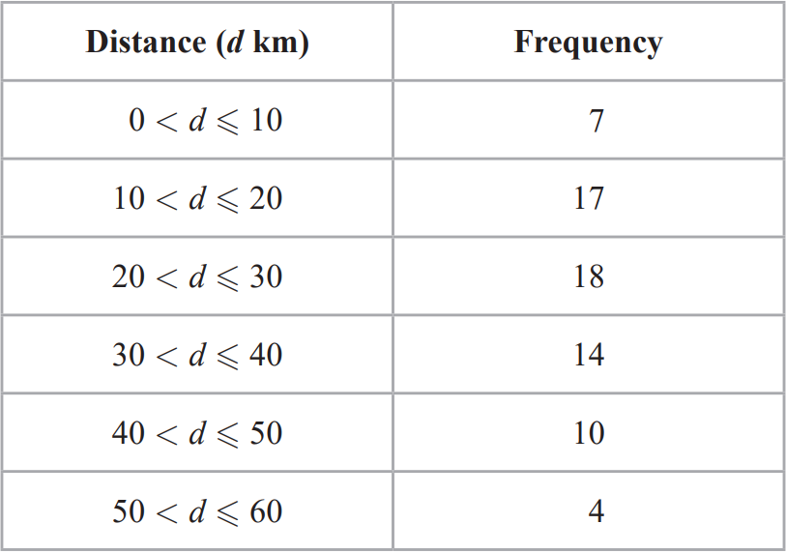

1. Complete the cumulative frequency table. [1]

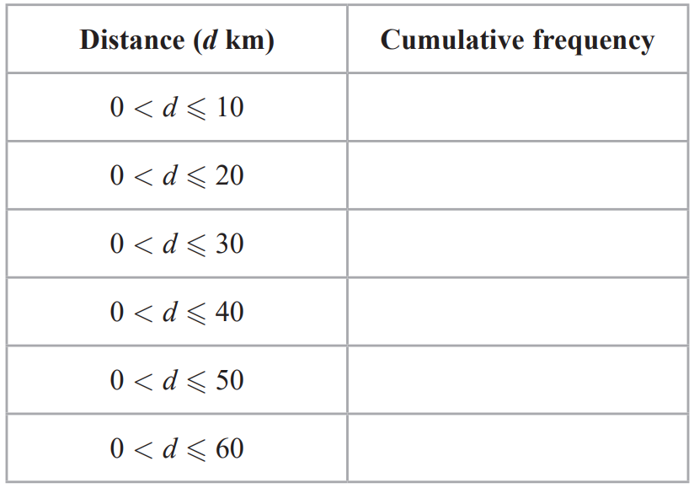

1. 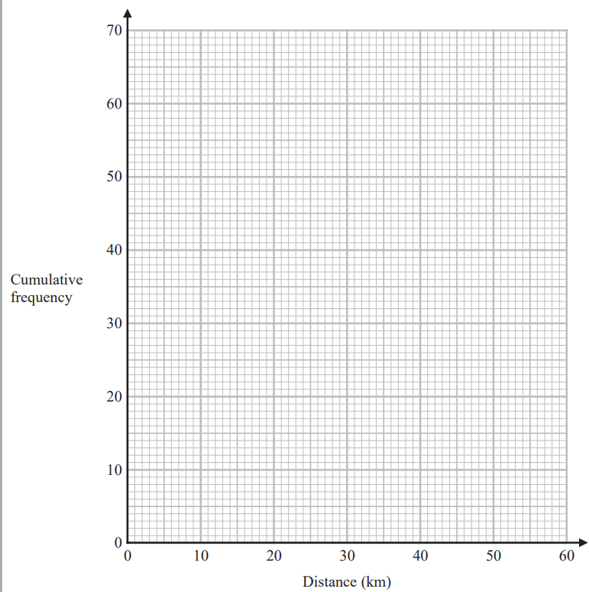On the grid opposite, draw a cumulative frequency graph for your table. [2]
2. Use your graph to find an estimate for the interquartile range of the distances. [2]
3. Use your graph to find an estimate for the number of teachers who travel more than 46 km. [2]

[MAY24 2H Q13]

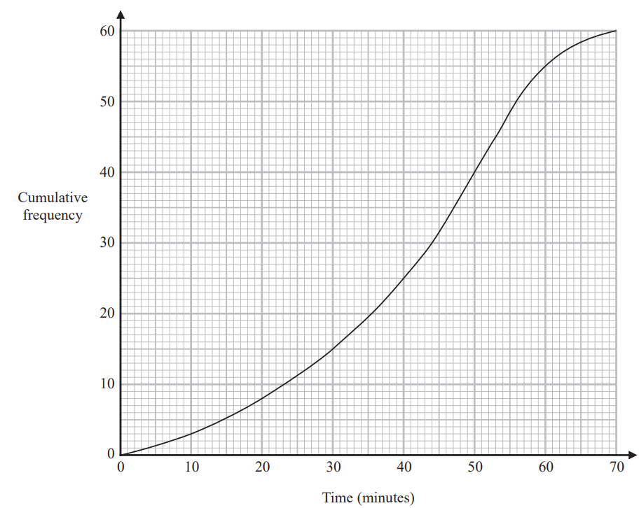Q4. The cumulative frequency graph gives information about the time, in minutes, each of 60 people took to shop in a market.

1. Use the graph to find an estimate for the median time people took to shop in the market.
2. Use the graph to find an estimate for the number of people who took longer than 55 minutes to shop in the market.
3. Use the graph to complete the frequency table to give information about the time, in minutes, each of the 60 people took to shop in the market.

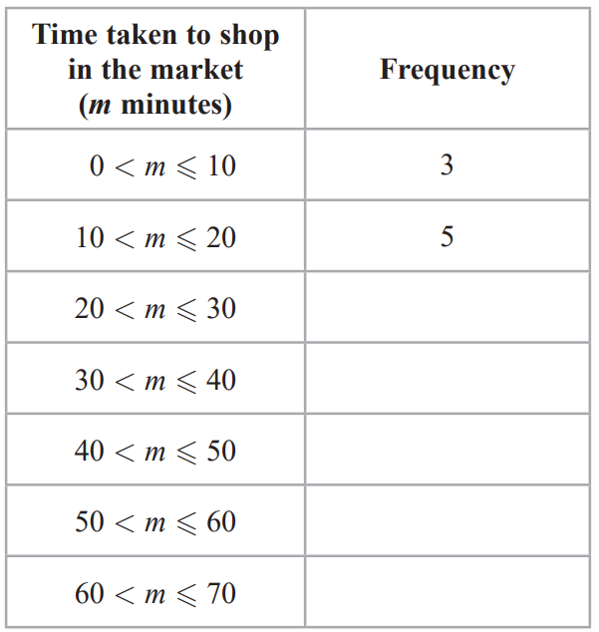[JAN23 2H Q12]

Q5. The table gives information about the ages, in years, of 80 people in a train carriage. 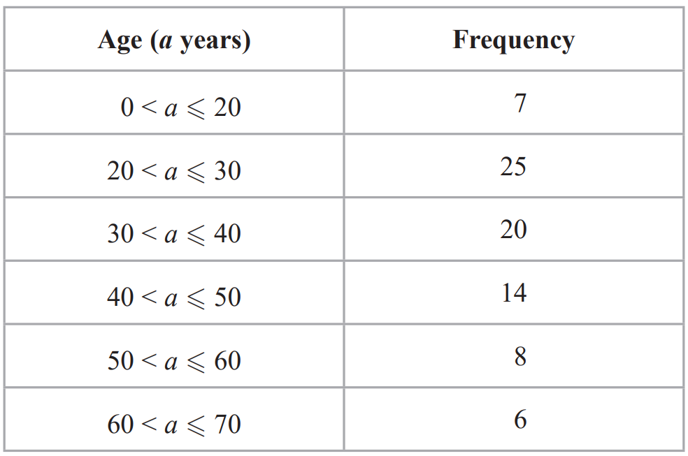

1. 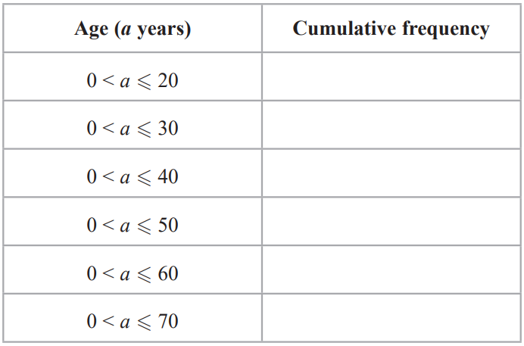Complete the cumulative frequency table.
2. On the grid opposite, draw a cumulative frequency graph for your table.
3. Use your graph to find an estimate for the median age of the 80 people.

Of the people in the train carriage, 60% of those who are aged between 18 and 65 are going to work. None of the other people in the train carriage are going to work.

1. Use your graph to find an estimate for the number of people in the train carriage who are going to work.

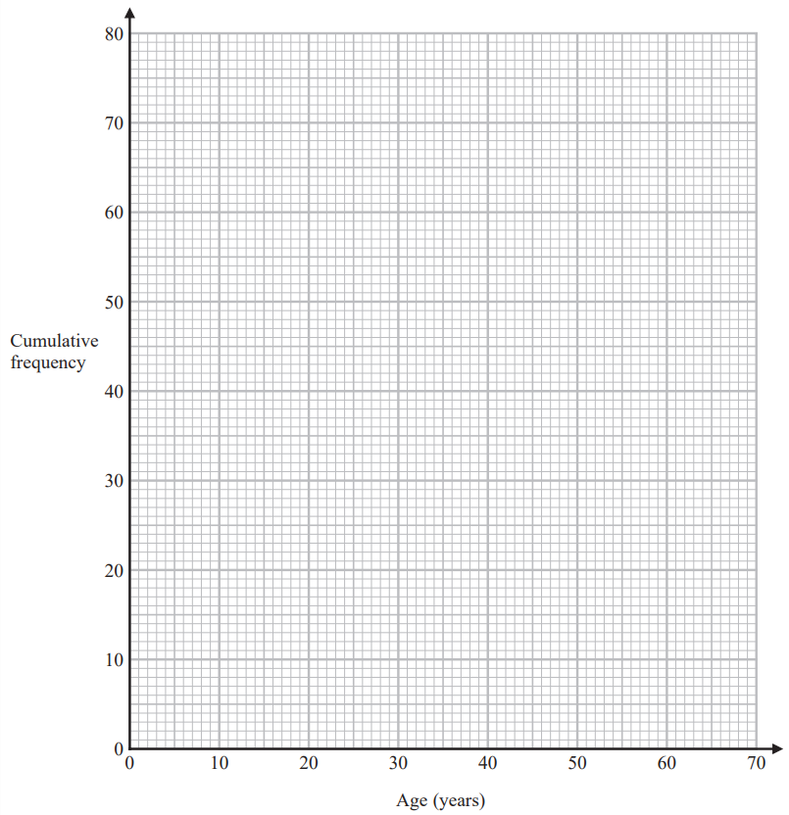

[MAY22 2H Q13]

Q6. The cumulative frequency table shows information about the ages of 60 people who went to a gym on Saturday

1. 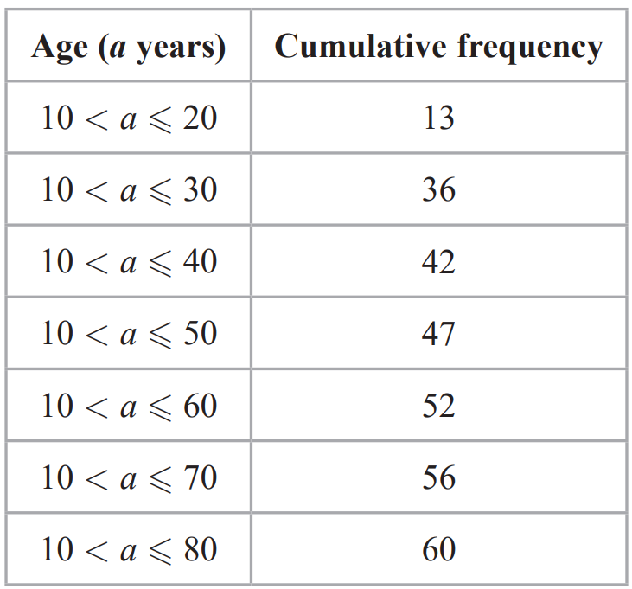On the grid, draw a cumulative frequency graph for the information in the table.

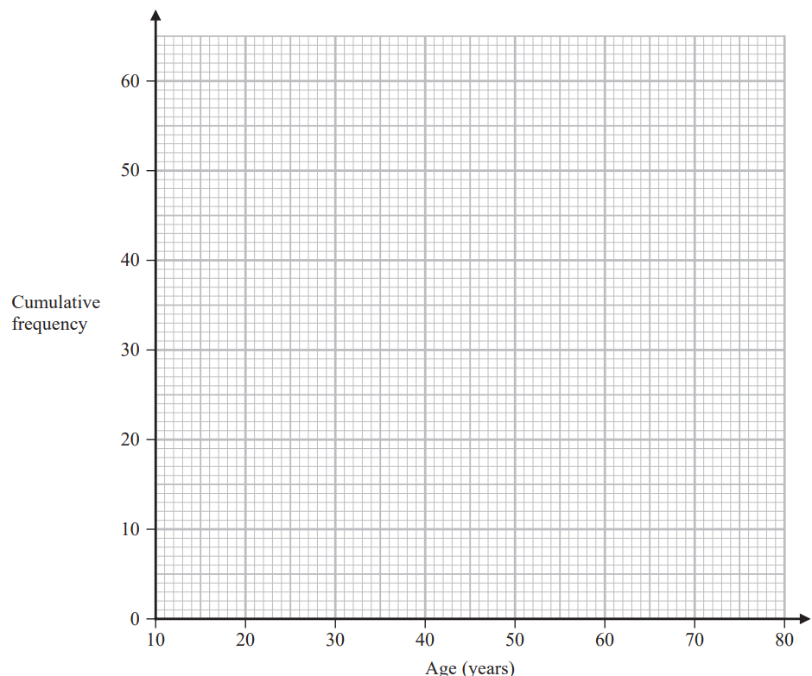

1. Use your graph to find an estimate for the median of the ages of these people.
2. Use your graph to find an estimate for the interquartile range of the ages of these people.
3. Use your graph to find an estimate for the number of these people who are older than 55 years.

[MAY22 2HR Q11]

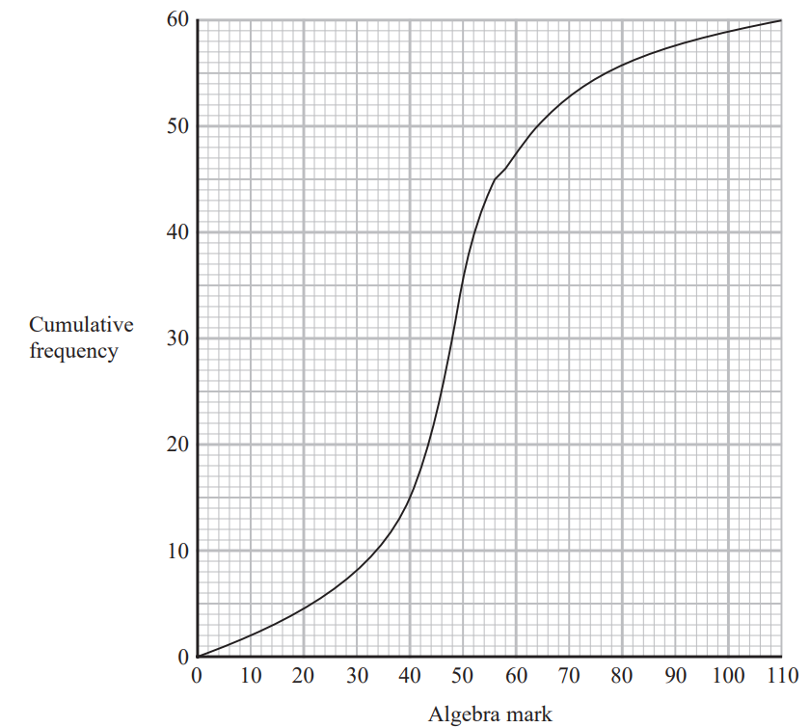Q7. A group of 60 students each sat an algebra test and a geometry test. Each test was marked out of 110 The cumulative frequency graph gives information about the marks gained by the 60 students in the algebra test.

1. Use the graph to find an estimate for the median mark in the algebra test.
2. Use the graph to find an estimate for the number of students who gained 58 marks or less in the algebra test.
3. Use the graph to find an estimate for the interquartile range of the marks gained in the algebra test.

The interquartile range of the marks gained in the geometry test is 9

Luis says

“The students’ marks are more spread out in the algebra test than in the geometry test.”

1. Is Luis correct? Give a reason for your answer.

[JAN22 2HR Q14]

Q8. The cumulative frequency table gives information about the distance, in kilometres, that each of 80 workers travel from home to work at Office A.

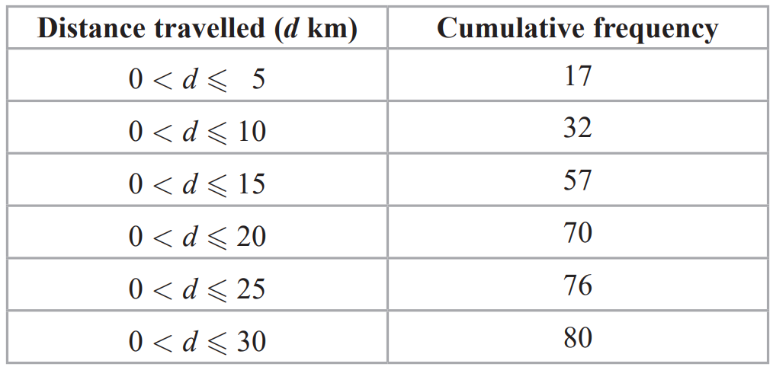

1. 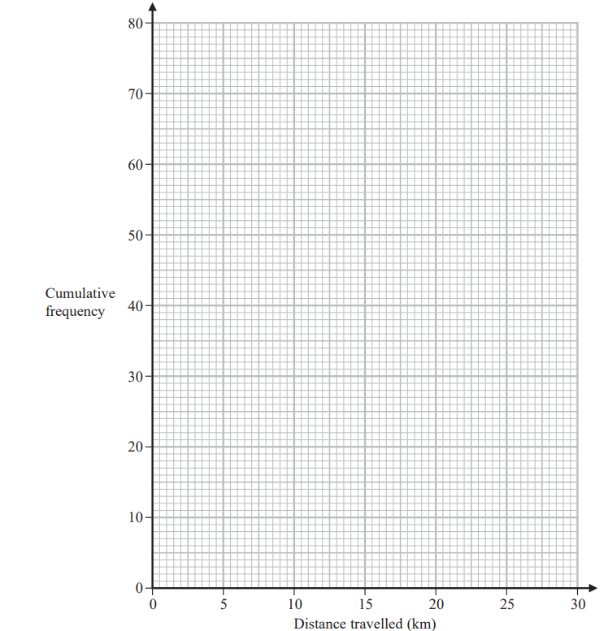On the grid below, draw a cumulative frequency graph for the information in the table.
2. Use your graph to find an estimate for the median distance travelled.
3. Use your graph to find an estimate for the interquartile range of the distances travelled

For Office B, the median distance workers travel from home to work is 15km and the interquartile range is 5km.

1. Use the information above to compare the distances that workers at Office A and workers at Office B travel from home to work. Write down **two** comparisons.

[MAY21 2H Q12]

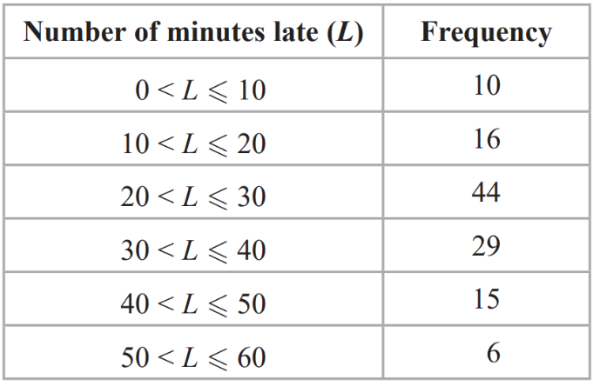Q9. The table shows information about the number of minutes each of 120 buses was late last Monday

1. 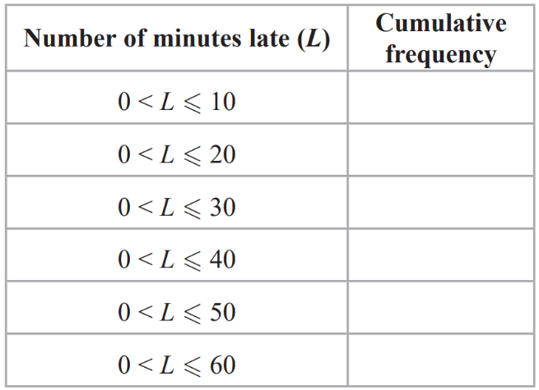Complete the cumulative frequency table below.
2. On the grid, draw a cumulative frequency graph for your table.
3. 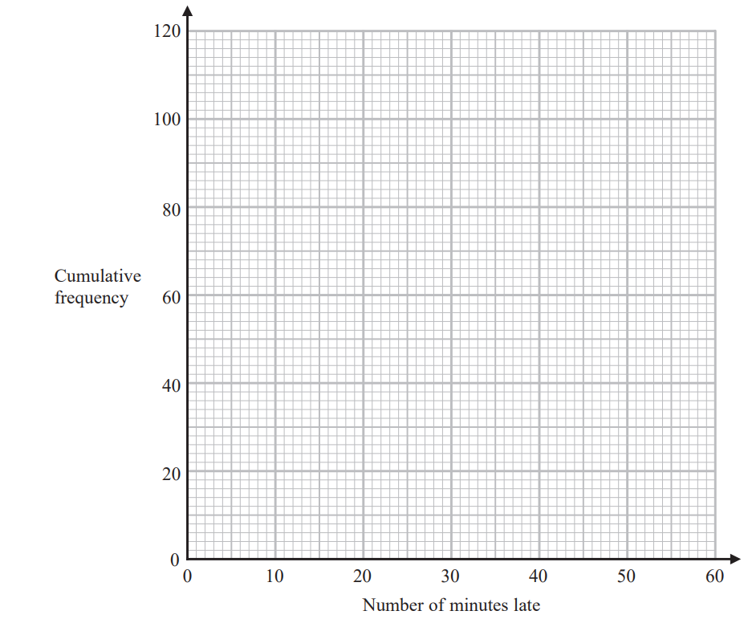Use your graph to find an estimate for the interquartile range.
4. ) Use your graph to find an estimate for the number of buses that were more than 48 minutes late last Monday

[MAY/NOV20 P2H Q14]

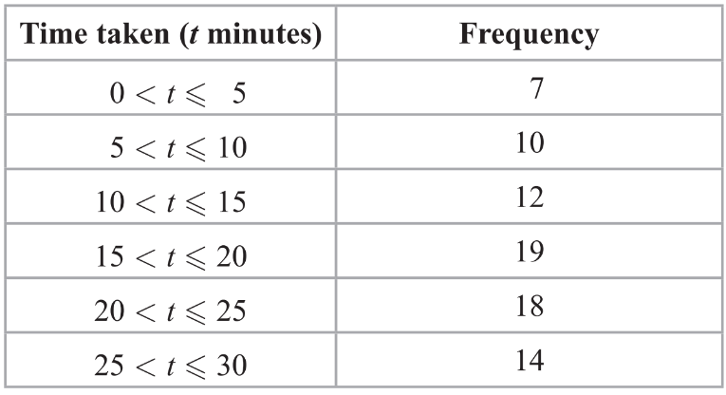Q10. The table gives information about the times taken, in minutes, for 80 taxi journeys.

1. Complete the cumulative frequency table.
2. 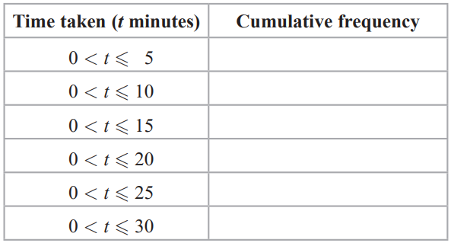On the grid opposite, draw a cumulative frequency graph for your table.

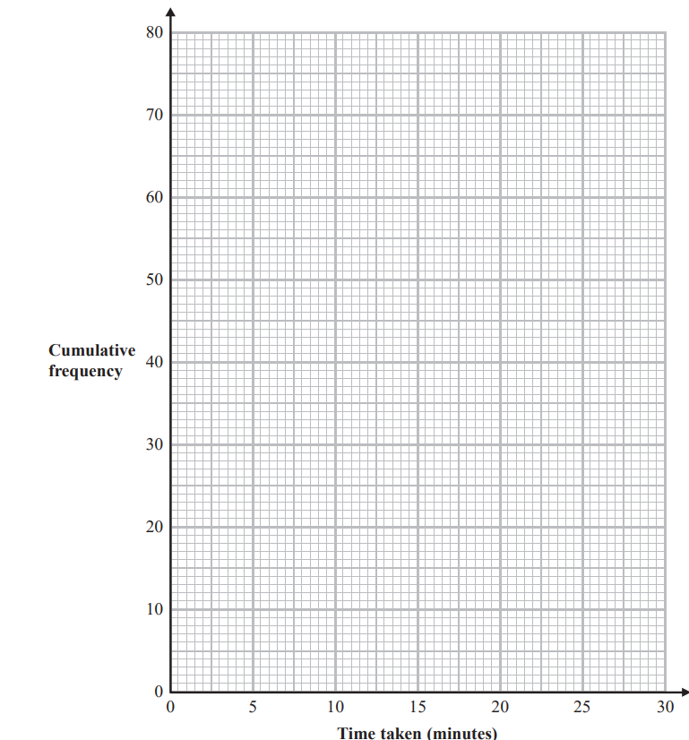

1. Use your graph to find an estimate for the median.
2. Use your graph to find an estimate for the interquartile range.

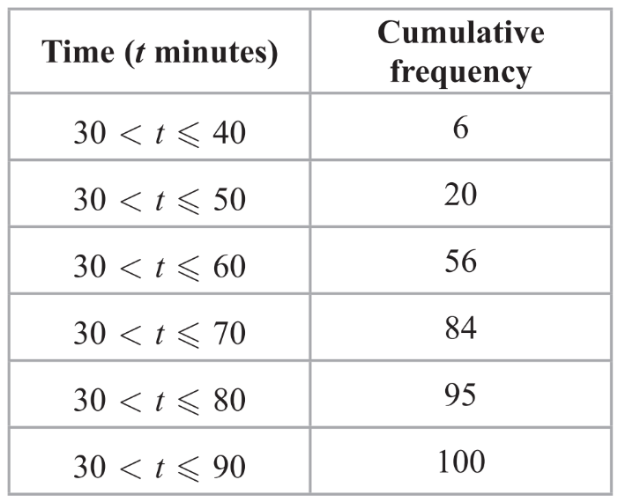Q11. Sandeep recorded the length of time, in minutes, that each of 100 adults went for a walk one Saturday afternoon. The cumulative frequency table gives information about these times.

1. 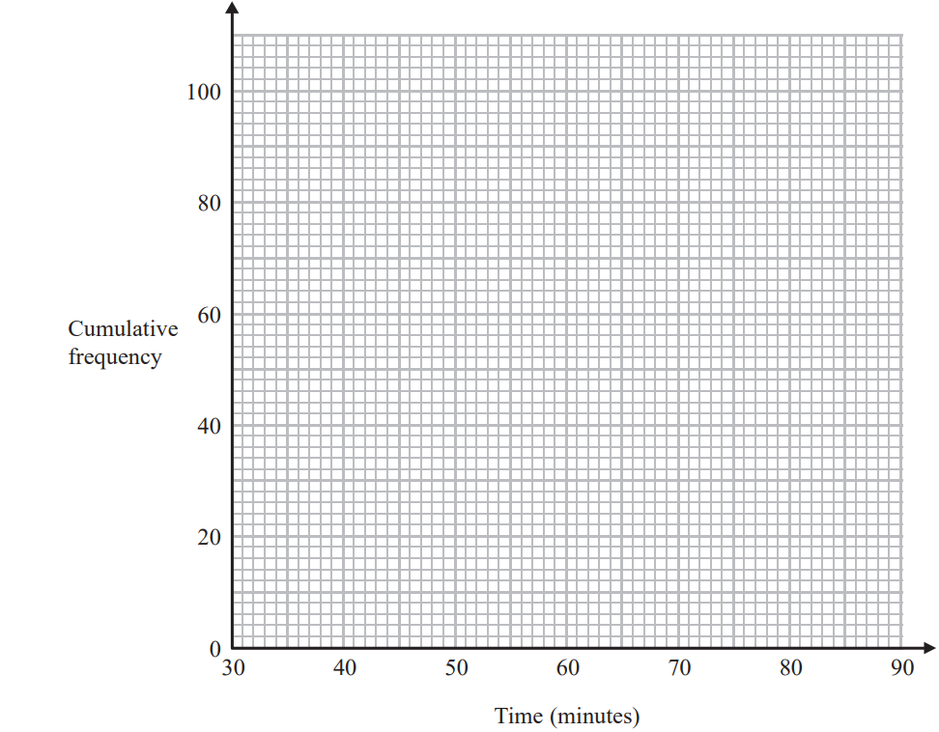On the grid, draw a cumulative frequency graph for the information in the table.
2. Use your graph to find an estimate for the median length of time that these adults went for a walk.

One of the 100 adults is chosen at random.

1. Use your graph to find an estimate for the probability that this adult went for a walk for more than 72 minutes.

[MAY19 2HR Q13]

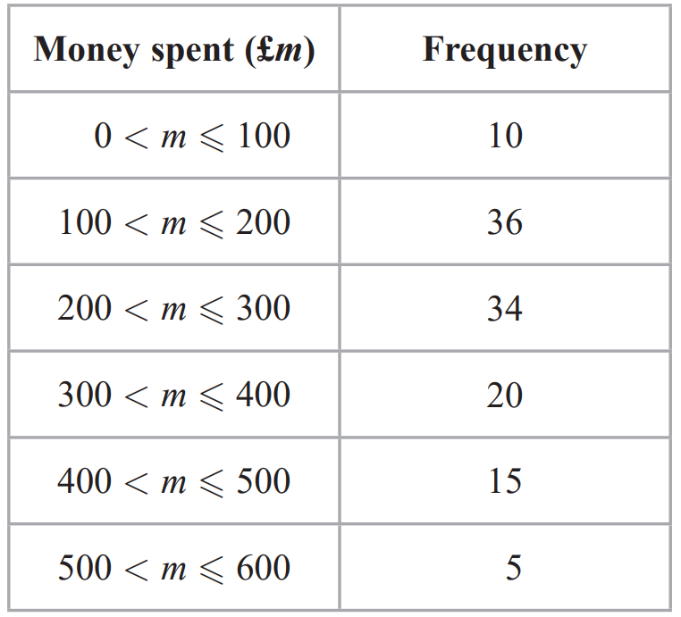Q12. The table shows information about the amount of money spent on holiday by each of 120 families.

1. Write down the modal class
2. 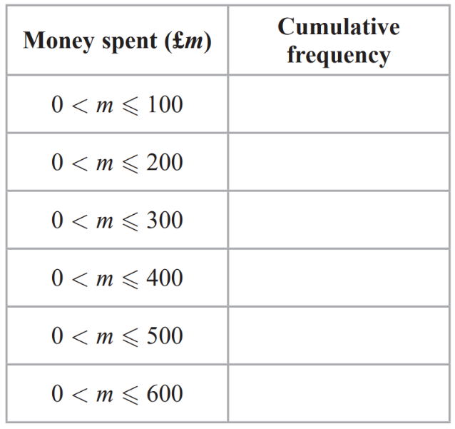Complete the cumulative frequency table for the information in the table.
3. On the grid, draw a cumulative frequency graph for your table.

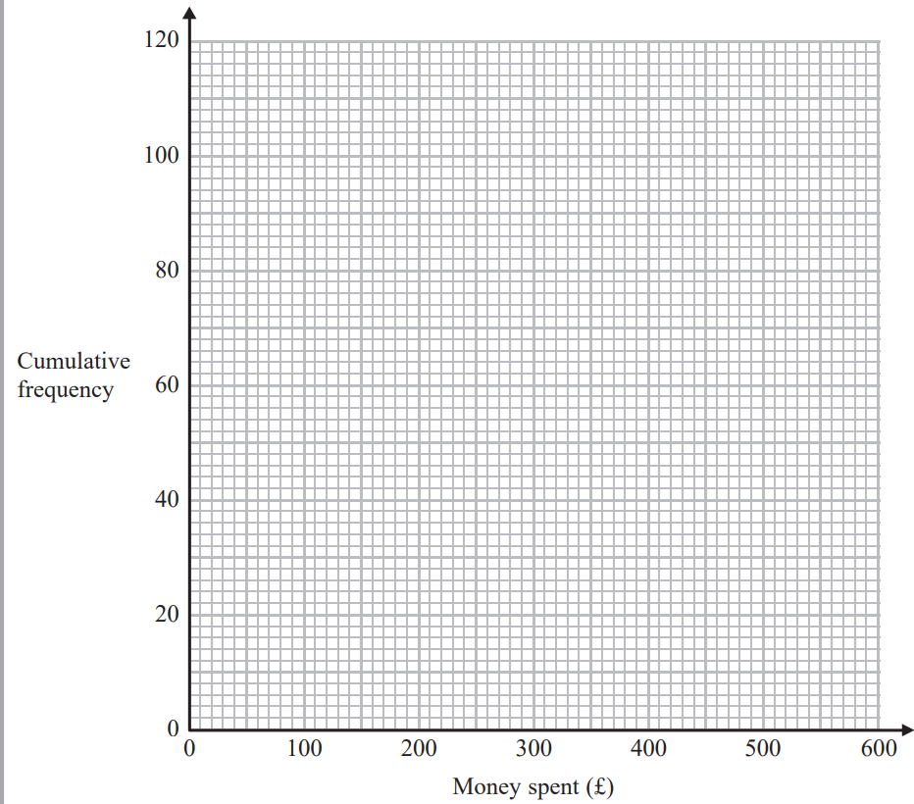

1. Use your graph to find an estimate for the interquartile range.
2. Use your graph to find an estimate for the number of families that spent more than £450 on holiday.

[MAY18 2HR Q11]

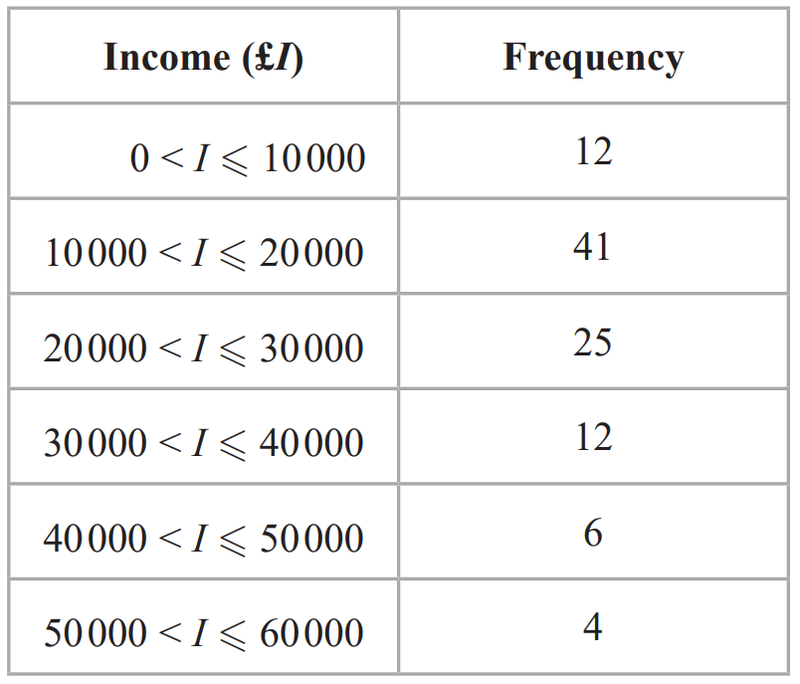Q13. The table gives some information about the incomes, £I, of 100 people in the UK.

1. Complete the cumulative frequency table.
2. 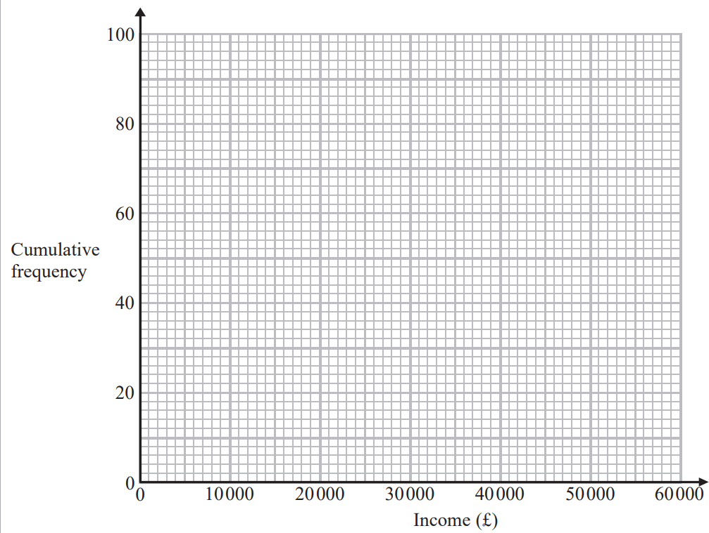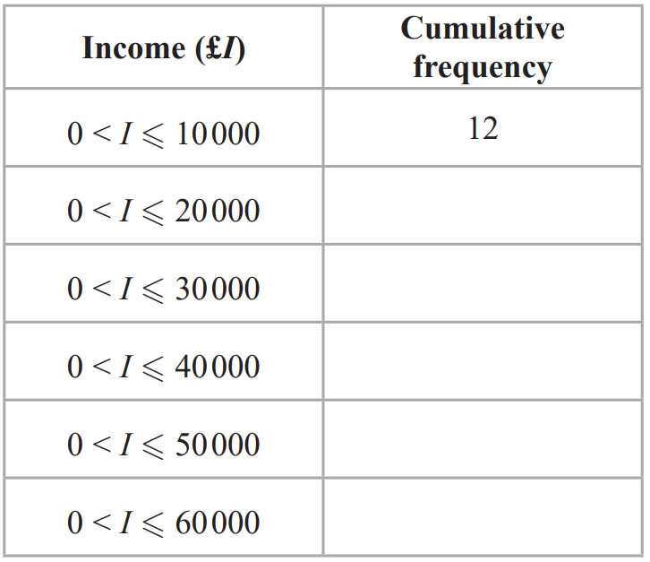On the grid, draw a cumulative frequency graph for your table.
3. Use your graph to find an estimate for
4. the median,
5. the interquartile range.

[MAY16 4HR Q12]

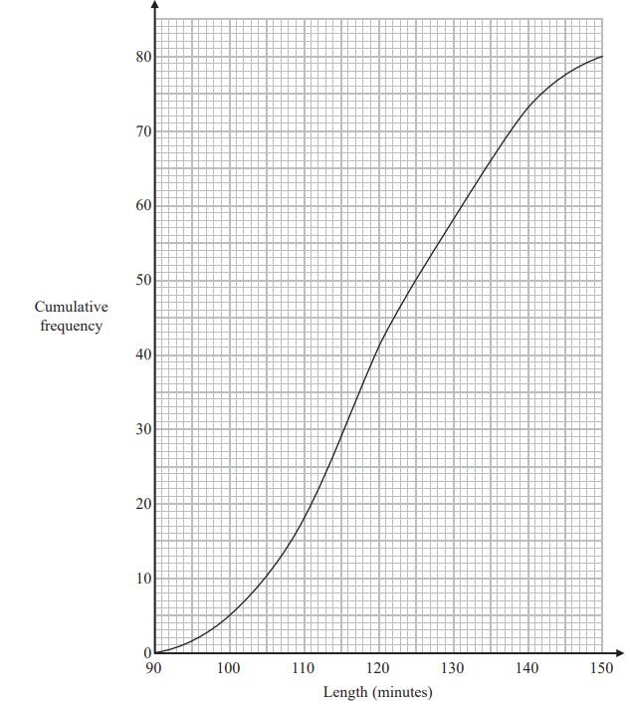Q14. The cumulative frequency graph shows information about the length, in minutes, of each of 80 films.

1. Find an estimate for the interquartile range.
2. Find an estimate for the percentage of the 80 films that lasted more than 125 minutes.

[MAY15 4H Q10]

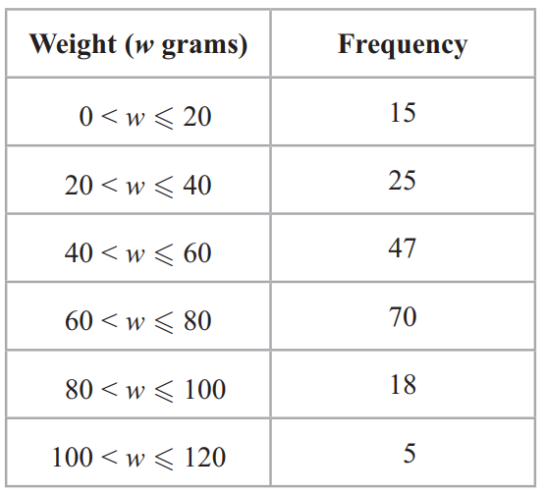Q15. The grouped frequency table gives information about the weights of 180 airmail letters.

1. 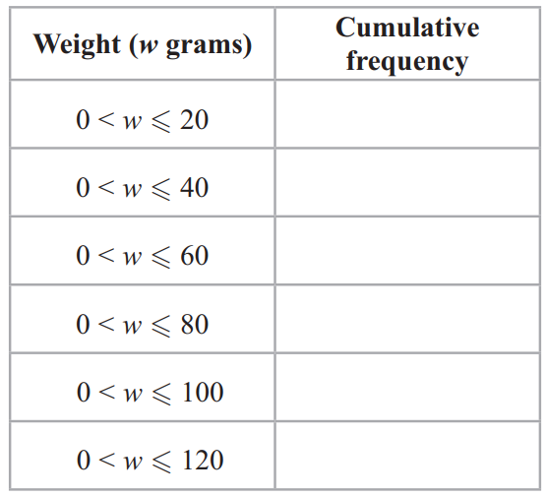Complete the cumulative frequency table.
2. On the grid, draw a cumulative frequency graph for your table.

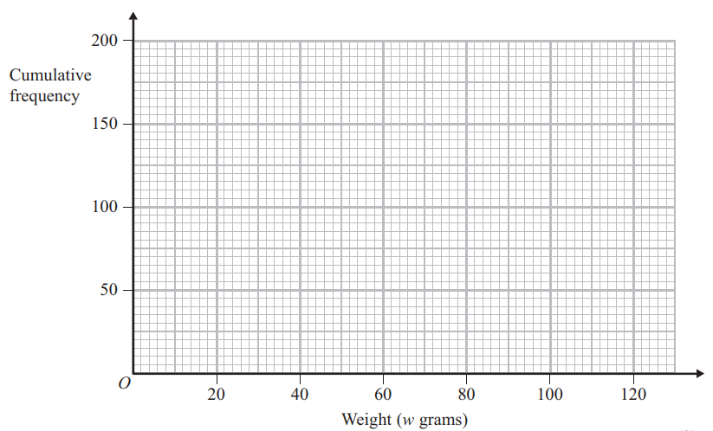

1. Find an estimate for the upper quartile of the weights of the 180 letters.

Q16. The cumulative frequency graph gives information about the heights of 80 sunflowers.

1. 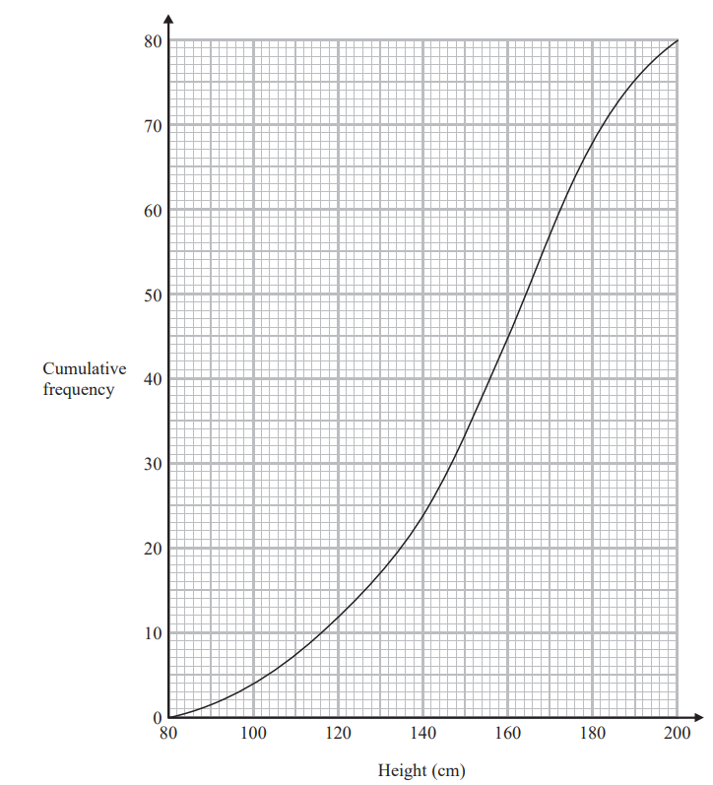Use the graph to find an estimate for the number of sunflowers with a height greater than 150 cm
2. Use the graph to find an estimate for the median.

[JAN18 4H Q12]

Q17. The cumulative frequency table shows information about the heights of 60 men.

1. 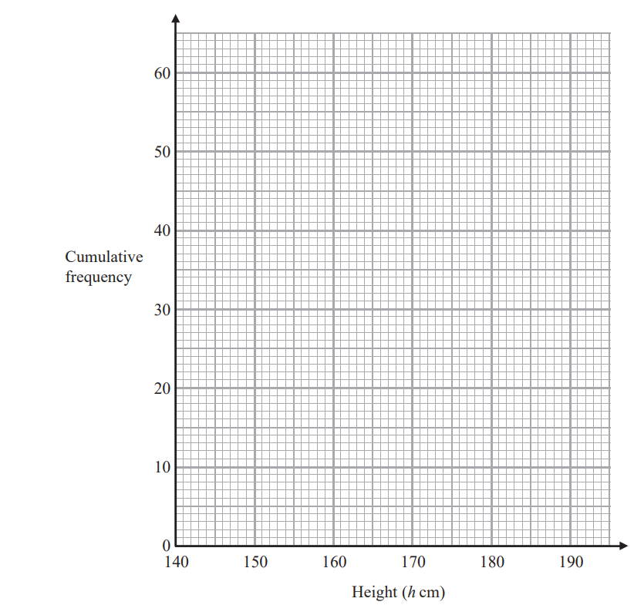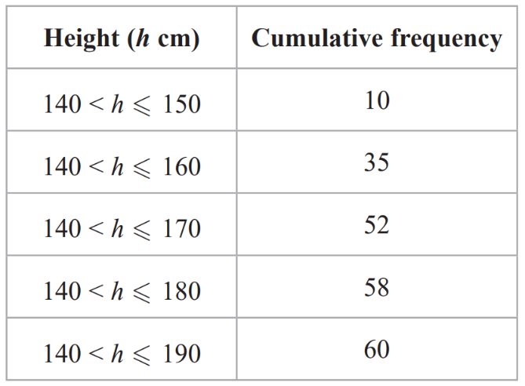On the grid, draw a cumulative frequency graph for the table.\
2. Use your graph to find an estimate for the median height of the 60 men.
3. Use your graph to find an estimate for the number of the men who are taller than 174cm.

[JAN16 4H Q15]

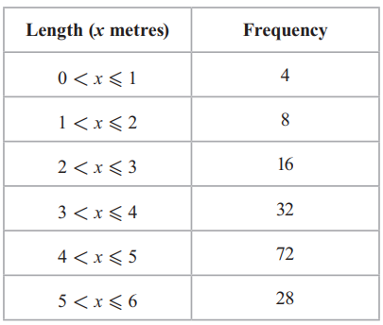Q18. The grouped frequency table gives information about the lengths of 160 pythons

1. 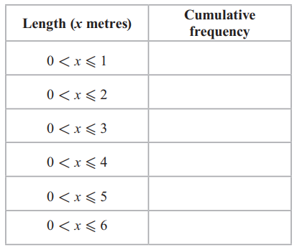Complete the cumulative frequency table.
2. 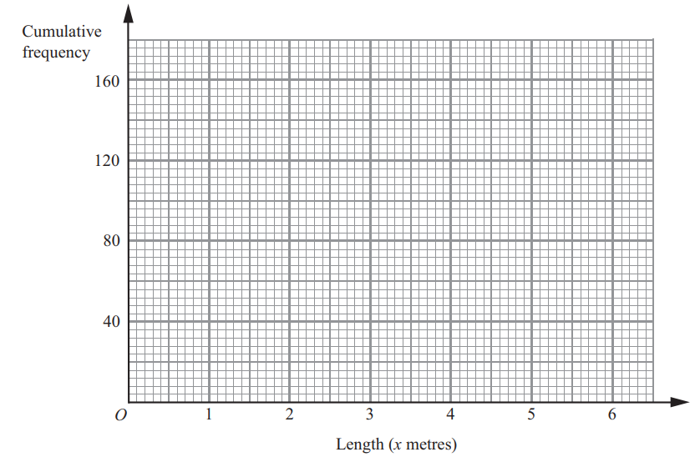On the grid, draw a cumulative frequency graph for your table
3. Use your graph to find an estimate for the median length of the pythons.

[JAN13 4H Q16]

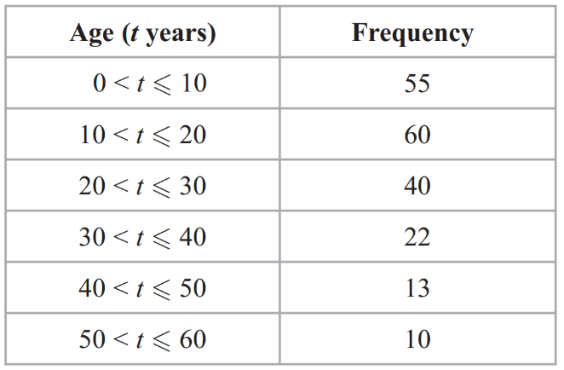Q19. The grouped frequency table gives information about the ages of 200 elephants.

1. 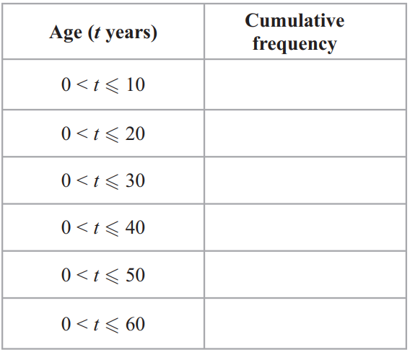Complete the cumulative frequency table.
2. 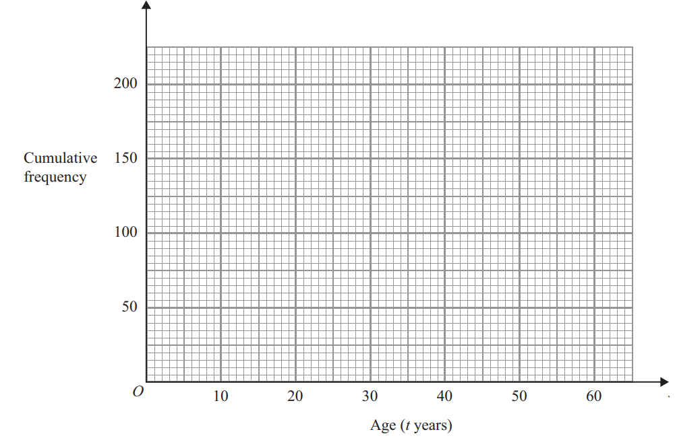On the grid, draw a cumulative frequency graph for your table.
3. Use the graph to find an estimate for the number of elephants with ages of more than 26 years.

[JAN12 4H Q14]